CCP REPORT
(CT-175)

Mini Shopping Cart in C

Submitted By:
1. Alishba Habib (153)
2. Daniya Ali (159)
3. Amber Tariq (163)

Course Instructor:
Muhammad Abdullah



CONTENTS

1.Title page 1
2. Objectives 3
3. Tools and Technologies 3
4. Project Description 3
5. Features 3
6. Flowchart ……………………………………………………….................................4
7. Source Code 5
8. Testing and Results 14
9. Future Enhancements 14
10. Conclusion 14

1.Project Title: Mini Shopping Cart

2.Objectives:
The objective of this project is to develop a console-based Mini Shopping Cart system in C language. It allows users to select categories, choose items, specify quantities, and calculate totals automatically with discounts applied based on the purchase amount.

3. Tools and Technologies:
• Programming Language: C
• Compiler: GCC (Dev-C++)
• Platform: Windows

4. Project Description:
This Mini Shopping Cart program is a text-based system created in the C programming language. It mimics the behavior of a real shopping cart where users can select different product categories such as Dairy, Meat, and Fruits, choose items, and enter quantities. The program automatically calculates the subtotal, applies a discount according to the total, and displays the final bill. This project demonstrates practical usage of loops, conditions, switch cases, and user-defined functions in C.

5. Features:
• Category-wise item selection
• Dynamic total and subtotal calculation
• Discount system based on total purchase
• Final bill with total, discount, and savings
• Error handling for invalid selections

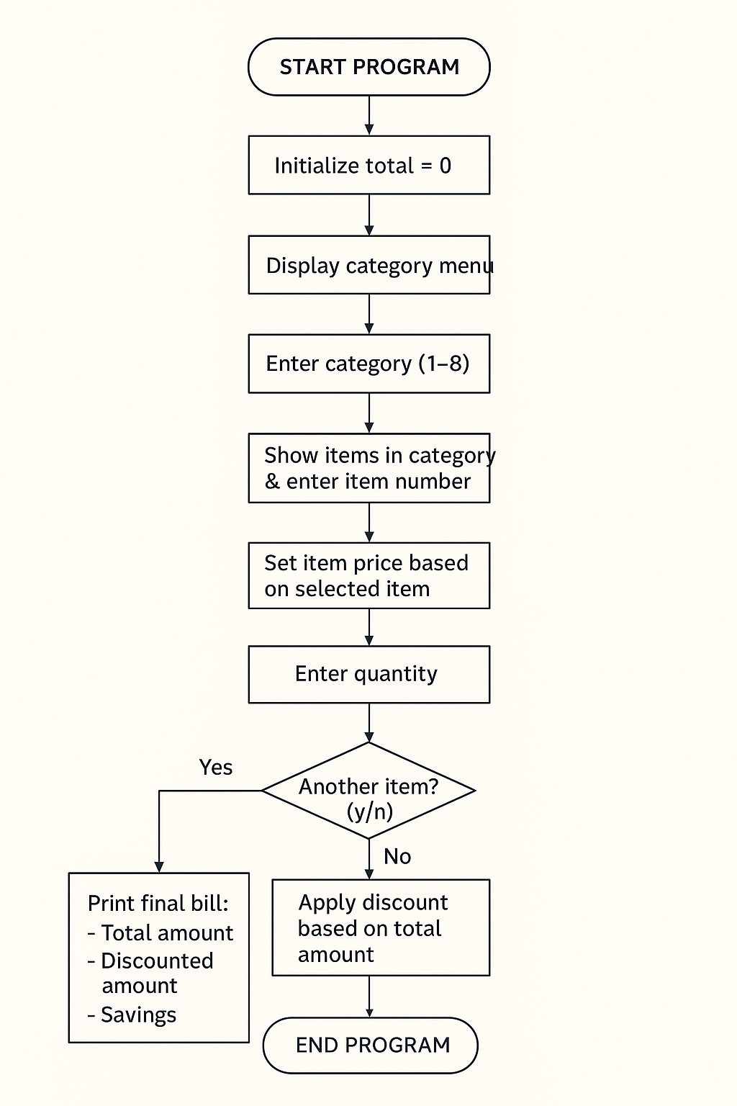
6.Flowchart:

7. Source Code:

Header files:
- <stdio.h>
- <string.h>

Functions:
- float discount_calc(float total);
- void bill(float total, float discountedTotal);
- void showCategories();

Variables:
- int category, item, quantity;
- float price = 0, itemTotal, total = 0, discountedTotal;
- char choice;

Conditional Statements:
- Switch statement
- If statement
- Nested if else statement

Iterative statement:
- Do while loop

Jump Statements:
- Return statement
- Continue statement
- Break statement

Function Body:
// Function to display the categories
void showCategories()
{
printf("\n================= CATEGORIES =================");
printf("\n1. Dairy");
printf("\n2. Meat");
printf("\n3. Cooking Stuff");
printf("\n4. Ready Made");
printf("\n5. Laundry");
printf("\n6. Fruits & Vegetables");
printf("\n7. Canned Stuff");
printf("\n8. Bath");
printf("\n==============================================\n");
}

// Function to apply discount
float discount_calc(float total)
{
float discount = 0;

if (total >= 10000)
discount = 0.40 * total;
else if (total >= 5000)
discount = 0.25 * total;
else if (total >= 3000)
discount = 0.15 * total;

return total - discount;
}

// Function to print the final bill
void bill(float total, float discountedTotal)
{
printf("\n==========================================\n");
printf("--------------- FINAL BILL ---------------\n");
printf("==========================================\n");
printf("Total Amount: Rs. %.2f\n", total);
printf("Discounted Amount: Rs. %.2f\n", discountedTotal);
printf("You Saved: Rs. %.2f\n", total - discountedTotal);
printf("------------------------------------------\n");
printf(" Thank you for shopping with us!\n");
printf("------------------------------------------\n");
}

Switch statement:
switch (category)
{
case 1: // Dairy section
printf("\n1. Milk (Rs. 180 per litre)");
printf("\n2. Cheese (Rs. 500 per pack)");
printf("\n3. Butter (Rs. 350 per pack)");
printf("\n4. Yoghurt (Rs. 250 per kg)");
printf("\nChoose item: ");
scanf("%d", &item);
if (item == 1)
price = 180;
else if (item == 2)
price = 500;
else if (item == 3)
price = 350;
else if (item == 4)
price = 250;
else{
printf("\nInvalid item selected! Please try again.\n");
continue;}
break;

case 2: // Meat section
printf("\n1. Chicken (Rs. 650 per kg)");
printf("\n2. Beef (Rs. 900 per kg)");
printf("\n3. Mutton (Rs. 1300 per kg)");
printf("\n4. Fish (Rs. 2000 per kg)");
printf("\nChoose item: ");
scanf("%d", &item);
if (item == 1)
price = 650;
else if (item == 2)
price = 900;
else if (item == 3)
price = 1300;
else if (item == 4)
price = 2000;
else{
printf("\nInvalid item selected! Please try again.\n");
continue;}
break;

case 3: // Cooking stuff
printf("\n1. Oil (Rs. 650 per litre)");
printf("\n2. Flour (Rs. 180 per kg)");
printf("\n3. Rice (Rs. 300 per kg)");
printf("\n4. Salt (Rs.50 per pack)");
printf("\n5. Sugar (Rs.100 per kg)");
printf("\n6. Beans (Rs.200 per kg)");
printf("\n7. Tea leaves (Rs.265 per pack)");
printf("\nChoose item: ");
scanf("%d", &item);
if (item == 1)
price = 650;
else if (item == 2)
price = 180;
else if (item == 3)
price = 300;
else if (item == 4)
price = 50;
else if (item == 5)
price = 100;
else if (item == 6)
price = 200;
else if (item == 7)
price = 265;
else{
printf("\nInvalid item selected! Please try again.\n");
continue;}

break;

case 4: // Ready made
printf("\n1. Bread (Rs. 180 per pack)");
printf("\n2. Biscuits (Rs. 120 per pack)");
printf("\n3. Cake (Rs. 500 per cake)");
printf("\nChoose item: ");
scanf("%d", &item);
if (item == 1)
price = 180;
else if (item == 2)
price = 120;
else if (item == 3)
price = 500;
else{
printf("\nInvalid item selected! Please try again.\n");
continue;}

break;

case 5: // Laundry
printf("\n1. Surf Excel (Rs. 550 per kg)");
printf("\n2. Ariel (Rs. 600 per kg)");
printf("\n3. Comfort (Rs. 250 per bottle)");
printf("\nChoose item: ");
scanf("%d", &item);
if (item == 1)
price = 550;
else if (item == 2)
price = 600;
else if (item == 3)
price = 250;
else{
printf("\nInvalid item selected! Please try again.\n");
continue;}

break;

case 6: // Fruits and Veggies
printf("\n1. Apples (Rs. 300 per kg)");
printf("\n2. Tomatoes (Rs. 150 per kg)");
printf("\n3. Potatoes (Rs. 120 per kg)");
printf("\nChoose item: ");
scanf("%d", &item);
if (item == 1)
price = 300;
else if (item == 2)
price = 150;
else if (item == 3)
price = 120;
else{
printf("\nInvalid item selected! Please try again.\n");
continue;}

break;

case 7: // Canned stuff
printf("\n1. Baked Beans (Rs. 250 per can)");
printf("\n2. Tuna (Rs. 350 per can)");
printf("\n3. Sweet Corn (Rs. 200 per can)");
printf("\nChoose item: ");
scanf("%d", &item);
if (item == 1)
price = 250;
else if (item == 2)
price = 350;
else if (item == 3)
price = 200;
else{
printf("\nInvalid item selected! Please try again.\n");
continue;}

break;

case 8: // Bath
printf("\n1. Soap (Rs. 180 per bar)");
printf("\n2. Shampoo (Rs. 400 per bottle)");
printf("\n3. Toothpaste (Rs. 250 per pack)");
printf("\nChoose item: ");
scanf("%d", &item);
if (item == 1)
price = 180;
else if (item == 2)
price = 400;
else if (item == 3)
price = 250;
else{
printf("\nInvalid item selected! Please try again.\n");
continue;}
break;
}

8. Testing and Results:
We tested the program under various input cases including:
• Normal purchase flow across multiple categories
• Invalid inputs and error handling
• Boundary cases for discount thresholds at Rs. 3000, 5000, and 10000
All tests passed successfully, and the output matched the expected results.

9. Future Enhancements:
• Add file handling to save and load shopping sessions
• Introduce arrays or structures to handle item data efficiently
• Add search, remove, or edit options in the cart
• Improve interface and implement advanced error handling

10. Conclusion:
Through this Mini Shopping Cart project, we learned how to apply fundamental C programming concepts to solve real-world problems. We gained hands-on experience in using loops, conditional statements, switch cases, and functions to design an interactive and user-friendly program. This project enhanced our problem-solving and logical thinking skills.

